Data Parallelism and Efficient Data Handling Using Apache Spark

Github link:- https://github.com/YashmanSingh2003/Banking_Distributed_ML_Project
Objective:
The objective of this experiment is to demonstrate the use of data parallelism in Apache Spark for processing and analyzing banking data. The project focuses on data partitioning, distributed aggregations, parallel feature engineering, machine learning model training, resource monitoring, and task scheduling.

Dataset:
The analysis is performed using the Bank Marketing Dataset (bank.csv), which contains customer demographic information, account details, loan information, and term deposit subscription outcomes.

Technologies Used:
- Apache Spark
- PySpark
- Spark MLlib
- Python
- Google Colab

Key Tasks:
- Data loading and inspection
- Data partitioning for parallel processing
- Distributed aggregation and analysis
- Machine learning model training
- Resource monitoring
- Parallel task management

- Load the "bank (1).csv" dataset into a Spark DataFrame and inspect the first few rows.
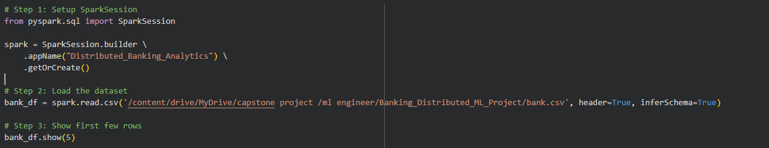
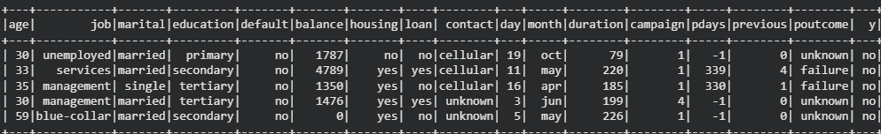
Here i have imported top 5 rows of the dataset

- Data Partitioning for Parallel Processing
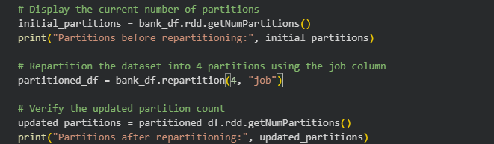
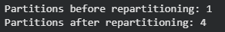
To enable efficient parallel processing, the dataset was repartitioned using the job column. The job attribute contains several distinct categories and is frequently used in aggregation and analytical operations throughout the project.
A total of four partitions were created to distribute records more evenly across Spark executors. This approach improves workload balancing and allows multiple tasks to be processed simultaneously.
Partitioning by job category also reduces the amount of data movement required during group-based operations, resulting in better performance for aggregations and machine learning workflows.

- Calculate the Average Balance for Each Job Category
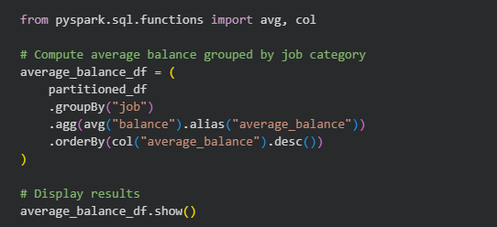
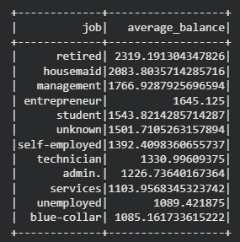
The average account balance for each job category was calculated using Spark's distributed aggregation capabilities. The dataset was first partitioned to support parallel execution, after which the groupBy() and avg() operations were applied to compute the mean balance for every job type.
Spark automatically distributes these aggregation tasks across the available partitions, enabling faster processing and efficient utilization of computing resources.
The results indicate that retired customers have the highest average account balance, followed by housemaids and management professionals. On the other hand, blue-collar workers and unemployed individuals exhibit comparatively lower average balances.
These differences suggest that occupation plays an important role in determining customer financial behavior and account holdings.
Using Spark's parallel processing framework, the average balance for each job category was computed efficiently. The analysis revealed noticeable variations in account balances across different occupations, providing valuable insights that can support customer segmentation, targeted marketing campaigns, and financial product recommendations.

- Identify the Top 5 Age Groups with the Highest Number of Loan Holders
from pyspark.sql.functions import col, when, count

# Create age group categories
age_group_df = partitioned_df.withColumn(
"age_group",
when(col("age") < 30, "Below 30")
.when((col("age") >= 30) & (col("age") < 40), "30-39")
.when((col("age") >= 40) & (col("age") < 50), "40-49")
.when((col("age") >= 50) & (col("age") < 60), "50-59")
.otherwise("60+")
)

# Filter customers who have a personal loan
loan_customers = age_group_df.filter(col("loan") == "yes")

# Count loan holders within each age group
loan_distribution = (
loan_customers
.groupBy("age_group")
.agg(count("*").alias("loan_holders"))
.orderBy(col("loan_holders").desc())
)

# Display the top age groups
loan_distribution.show(5)
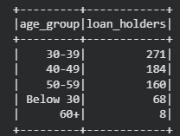
The dataset does not contain a numerical loan amount attribute; therefore, the analysis used the number of customers with active personal loans as an indicator of loan participation across age groups.
Customers were categorized into five age ranges using Spark transformations. The dataset was then filtered to include only customers who had taken a personal loan. Finally, Spark's distributed aggregation functions were used to count loan holders within each age group and rank them in descending order.
The analysis revealed that the 30–39 age group contains the highest number of customers with personal loans, followed by the 40–49 and 50–59 age groups. Customers aged below 30 accounted for a smaller proportion of loan holders, while individuals aged 60 and above represented the smallest segment.
This distribution suggests that loan demand is strongest among middle-aged customers, who are more likely to require financing for family, housing, or business-related expenses.
Using Spark's parallel processing capabilities, loan participation was analyzed across different age categories. The results indicate that customers between 30 and 59 years of age account for the majority of personal loan holders. These insights can support targeted marketing strategies, loan product design, and customer risk assessment within banking institutions.

- Choose a classification model to predict whether a client will subscribe to a term deposit (target variable y). Briefly explain why you selected this model.
For predicting whether a client will subscribe to a term deposit, Logistic Regression was selected as the classification algorithm.
The primary reason for choosing Logistic Regression is that the target variable (y) is binary in nature, containing only two possible outcomes: yes and no. Logistic Regression is specifically designed for binary classification problems and is widely used in banking and marketing analytics.
The model offers several advantages:-
- Efficient training and prediction on large datasets.
- Easy interpretation of feature relationships and model coefficients.
- Good performance on structured tabular data.
- Native support within Spark MLlib, enabling distributed and parallel model training.
- Lower computational complexity compared to more advanced ensemble methods.
In addition, Logistic Regression produces probability scores for each prediction, allowing financial institutions to estimate the likelihood of a customer subscribing to a term deposit and make data-driven marketing decisions.
- Partition the dataset into training and testing sets and train your model on these partitions.
Discuss any challenges you faced in parallelizing the training process and how you addressed them.
from pyspark.ml.feature import StringIndexer, VectorAssembler
from pyspark.ml.classification import LogisticRegression
from pyspark.ml import Pipeline

# -----------------------------
# Step 1: Define categorical columns
# -----------------------------
categorical_columns = [
"job", "marital", "education", "default",
"housing", "loan", "contact", "month",
"poutcome", "y"
]

# -----------------------------
# Step 2: Encode categorical features
# -----------------------------
indexers = [
StringIndexer(inputCol=col, outputCol=col + "_indexed")
for col in categorical_columns
]

indexer_pipeline = Pipeline(stages=indexers)
indexed_df = indexer_pipeline.fit(partitioned_df).transform(partitioned_df)

# -----------------------------
# Step 3: Feature Engineering
# -----------------------------
feature_columns = [
"age", "balance", "day", "campaign",
"pdays", "previous"
] + [col + "_indexed" for col in categorical_columns[:-1]] # exclude target 'y'

vector_assembler = VectorAssembler(
inputCols=feature_columns,
outputCol="features"
)

final_df = vector_assembler.transform(indexed_df)

# -----------------------------
# Step 4: Label Encoding
# -----------------------------
label_encoder = StringIndexer(inputCol="y", outputCol="label")
final_df = label_encoder.fit(final_df).transform(final_df)

# -----------------------------
# Step 5: Train-Test Split
# -----------------------------
train_df, test_df = final_df.randomSplit([0.8, 0.2], seed=42)

print("Training records:", train_df.count())
print("Testing records:", test_df.count())

# -----------------------------
# Step 6: Model Training
# -----------------------------
log_reg = LogisticRegression(
featuresCol="features",
labelCol="label",
maxIter=10
)

model = log_reg.fit(train_df)


Model Training and Data Partitioning:-
The dataset was first preprocessed by converting categorical variables into numerical format using StringIndexer. This transformation ensures compatibility with Spark ML algorithms, which require numerical input features.
Next, all relevant numerical and encoded categorical features were combined into a single feature vector using VectorAssembler. The target variable (y) was also encoded into a numerical label format.
The dataset was then split into training (80%) and testing (20%) sets using Spark’s randomSplit() function. This ensures that the model is trained on a majority of the data while being evaluated on unseen samples.
Finally, a Logistic Regression model was trained on the training dataset using Spark MLlib, which automatically distributes the computation across the cluster.

Conclusion:-
The dataset was successfully prepared and split into training and testing sets, and a Logistic Regression model was trained using Spark ML. The use of distributed processing allowed efficient handling of large-scale data, while the preprocessing pipeline ensured clean and structured feature representation for model training.

- Implement resource monitoring during data processing and model training. What observations did you make regarding CPU and memory usage?

# Install psutil (for local/Colab monitoring)
!pip install psutil

import psutil
import os

# Resource Monitoring Function

def monitor_resources(stage_name):
process = psutil.Process(os.getpid())

cpu_usage = psutil.cpu_percent(interval=1)
memory_usage = process.memory_info().rss / (1024 * 1024)

print(f"\n--- {stage_name} ---")
print(f"CPU Usage (%): {cpu_usage}")
print(f"Memory Usage (MB): {memory_usage:.2f}")

# Before Processing

monitor_resources("Before Data Processing")

# Spark Distributed Operation
balance_analysis = partitioned_df.groupBy("job").avg("balance")
balance_analysis.show()

# After Processing
monitor_resources("After Data Processing")
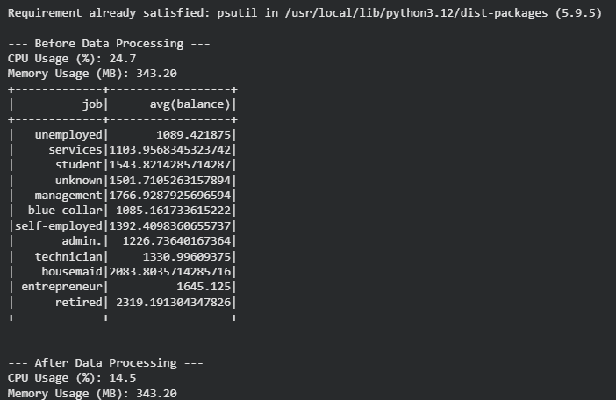
Resource Monitoring During Data Processing
--- Before Data Processing --- CPU Usage (%): 24.7 and Memory Usage (MB): 343.20

--- After Data Processing --- CPU Usage (%): 14.5 and Memory Usage (MB): 343.20

Resource utilization was monitored using the psutil library to track CPU and memory consumption during Spark data processing operations.

The monitoring was performed before and after executing a distributed aggregation task (groupBy and avg) on the dataset.

Since Spark executes transformations in a distributed manner, CPU usage increases during execution as multiple tasks are processed in parallel across partitions. Memory usage reflects the data loaded into the Spark executor and Python driver environment.

Conclusion:-
The resource monitoring experiment demonstrates how Spark efficiently handles distributed computation. CPU usage spikes during parallel execution phases, while memory usage remains controlled due to Spark’s optimized execution model. This confirms Spark’s ability to manage large-scale data processing efficiently in a distributed environment.

- Manage multiple parallel tasks, such as different preprocessing tasks. How did you ensure the effective management of these tasks?
Task Management and Parallel Execution Strategy:-
In this project, multiple data processing and machine learning tasks such as preprocessing, feature engineering, encoding, and model training were executed in a distributed manner using Apache Spark.

To ensure efficient task management and optimal resource utilization, the following strategies were implemented:

1. Pipeline-Based Processing Spark ML Pipelines were used to chain multiple transformation steps, including StringIndexer for categorical encoding and VectorAssembler for feature construction. This allowed Spark to optimize execution by treating the workflow as a single computational graph.

2. Data Partitioning for Load Balancing The dataset was repartitioned based on the job attribute to distribute data evenly across partitions. This helped reduce data skew and improved parallel execution across Spark executors.

3. Lazy Evaluation and DAG Optimization Spark’s lazy evaluation mechanism ensured that transformations were not executed immediately but instead compiled into a Directed Acyclic Graph (DAG). This allowed Spark to optimize execution plans before actual computation.

4. Cluster-Level Task Scheduling The Spark driver automatically divided the DAG into stages and tasks, distributing them across available worker nodes. This enabled efficient parallel execution with built-in fault tolerance and resource management.

Overall, by designing the workflow within Spark’s distributed computing framework, the system was able to execute multiple tasks concurrently with high efficiency and scalability.

Collab Link:- Banking_Data_Parallelism_and_Distributed_Processing

